Welcome to Medway Council’s Recruitment Information pack, which brings together all the information you may require about working with us. If you have any further questions, please contact us directly at recruitment@medway.gov.uk.

Your Application and our Recruitment Process

Applying for a job

Medway Council’s Equal Opportunities Policy and Recruitment and Selection Framework identify that we strive to ensure that every applicant is treated fairly. In making recruitment decisions we will not consider previous applications or any personal knowledge of you.

The information that you supply to us in your online application must include all the information requested. This is all we will use in deciding whether you will be shortlisted for interview. It is, therefore, very important for you to read the job profile/description fully and identify, in your application and personal statement; how you meet all the required knowledge, skills and experience.

Please be advised that (due to the number of applications we receive for our roles) if you are not contacted within 3 weeks of the advert closing date, then you have not been shortlisted.

Please note – previous employees of Medway Council who leave on the grounds of early retirement or redundancy are not eligible to be re-employed for six months, without prior consent of the employing Director, and the Chief Organisational Culture Officer.

Shortlisting and interviews

Applicants will be scored against their ability to meet the requirements of the person specification and will be shortlisted for interview. In addition, the Council may conduct additional skills tests and/or written exercises to enhance the selection process. You may be asked to undertake such exercises as part of the selection process and you will be notified of this alongside your invite to interview.

A diverse interview panel of Council officers will conduct the interview and ask questions which are intended to allow you to expand on your application, and to demonstrate how you meet the requirements of the post. This is also your opportunity to ask questions relating to the job, terms and conditions, hours of work etc.



Disability Confident Employer

Medway Council is proud to be a Disability Confident Employer meaning we think differently about disability and have taken action to improve how we recruit, retain and develop people with health conditions or impairments. We aim to identify appropriate workplace changes or adjustments to support employees with a disability or health condition to reach their full potential and thrive at work.

If you have a disability and meet the minimum eligibility criteria detailed in the job profile, you will be shortlisted for interview and we will discuss with you the ways in which the role can be modified to meet your needs, if required. If you experience any problems whilst trying to apply for a council vacancy, please send an email to recruitment@medway.gov.uk and we will be happy to assist you.

Fair recruitment

Medway Council puts great importance on ensuring that every stage of the recruitment process is carried out fairly and properly. We have a duty to ensure that everyone is treated in a non-discriminatory way.

Equal Opportunities Commitment Statement

“No service user, employee or job applicant will be discriminated against, harassed or receive less favourable treatment on the grounds of gender, race, colour, ethnic or national origin, disability, marital status, family commitments, sexual orientation, age, HIV status, religious or political beliefs, social class or trade union activity or irrelevant spent conviction”.

We hope that you will feel that you have been treated fairly, even if you are not appointed. If you want to discuss why you have not been successful, please contact, in the first instance, the manager who interviewed you who will be able to give you verbal feedback.

If you remain dissatisfied after this response, you should write to the head of HR Services, the Chief Organisational Culture Officer, via recruitment@medway.gov.uk; giving details of the post you have applied for and your reasons for dissatisfaction. We will ensure that the matter is properly investigated. If your complaint is upheld, we will review, as appropriate, our recruitment procedures.

Medway Council is committed to safeguarding and promoting the welfare of children, young people and vulnerable adults, and recruits to posts using safer recruitment methods as recommended by the Bichard Inquiry and the Warner report.

Our Values and Behaviours

Our values and behaviours guide us in all we do and show the kind of organisation we are.

- We are Proud to be Medway – taking pride in everything we do.
- We are Caring – compassionate towards our communities and colleagues
- We are Respectful – valuing Medway’s diversity, heritage and each other
- We are Trusted – we do what we say, we are open and accountable
- We are Ambitious for Medway – innovative, bold and positive
- We are Collaborative – working together – One Medway

Main conditions of employment details:

If you are successful at interview and offered a role with us; the employment will be subject to the conditions prescribed by the National Joint Council for Local Government Services, except where varied by local agreements or other National Conditions; which will be advised separately within the offer letter and accompanying Statement of Particulars.

Salaries

The salary of the post you have applied for will be shown as a range within the advert. Medway Council is currently implementing a refresh of its appraisal and pay scheme by introducing MedPay - Performance, Progression, Pay. This new scheme includes a performance-related pay element, meaning that staff can progress through set spot points at A, B & C levels of the salary range, by demonstrating how they meet the required skills, knowledge and experience for each level. This gives a real opportunity for anyone who is keen to develop and progress their career; with salary increases rewarding development in role.

Probation

If you are a new entrant to local government service or have had a break from continuous local government employment, your appointment is subject to a satisfactory probationary period of a minimum of six months from the commencement of your employment. During your probationary period you will be supported to establish your suitability for the post.
Annual Leave

Medway Council has a generous annual leave package with a minimum starting entitlement between 23 and 27 days (dependent on terms and conditions of employment and salary range) excluding Bank Holidays and an additional ex-gratia day (to be taken alongside the Christmas Bank Holidays) giving a minimum starting total annual leave allowance of 32 days; rising to a maximum of 39 days after 5 years continuous service, 40 after 10 years and 41 days after 15 years’ service.

All new entrants to local government are entitled to annual leave in proportion to the completed days of service in the first leave year. Part-time employees have an equal annual leave entitlement, in proportion to the number of hours being worked.

Car allowances

You may be entitled to a casual, essential or dedicated car user allowance, depending on your new work role, the amount of which depends on the cubic capacity of your car. If the post is classed as a dedicated car user, you will also be entitled to the Council’s Limited Lease Car Scheme. This comes with a reasonable annual contribution expected from employees. Petrol only mileage rates will be claimable.

Politically restricted posts

The Local Government and Housing Act 1989 and Local Government (Politically Restricted Posts) Regulations 1990 place certain restrictions on some Local Government employees so that they are prevented from taking part in political activities. Ordinarily this will be posts where the grade is Range 6/SW3 or above. If the post you have applied for is covered by these restrictions, you will be given further information as to what this means for you, within your offer letter and Statement of Particulars.

Working arrangements

Medway Council seeks to ensure our staff enjoy a good work-life balance. Our standard working week is 37 hours, Monday to Friday. You may be required to work unsocial hours and/or on a rota system, depending on the work role, but the actual hours of work will be confirmed at interview. For many posts Medway Council promotes flexible working hours. Further details of the working arrangements for this post will be discussed if you are invited to attend interview.

Press Pause is our Council initiative to remind and encourage all colleagues to take short breaks during their work time. This campaign is for everyone, whatever their level of work role and is a simple way to prevent fatigue at work is to give yourself time throughout the day to recharge.
Our minds need time to rest just as much as our bodies do. Taking short breaks can help us get into the habit of taking care of ourselves. Regular downtime during the day supports mental health by reducing anxiety, stress and fatigue.

Working location

As part of Medway Council’s “Ours Ways of Working” Policy, there are 4 recognised workstyles - detailed in the matrix below. Each role within the organisation will have a work style attached to it. The relevant work style for each role will be detailed in the recruitment advert.

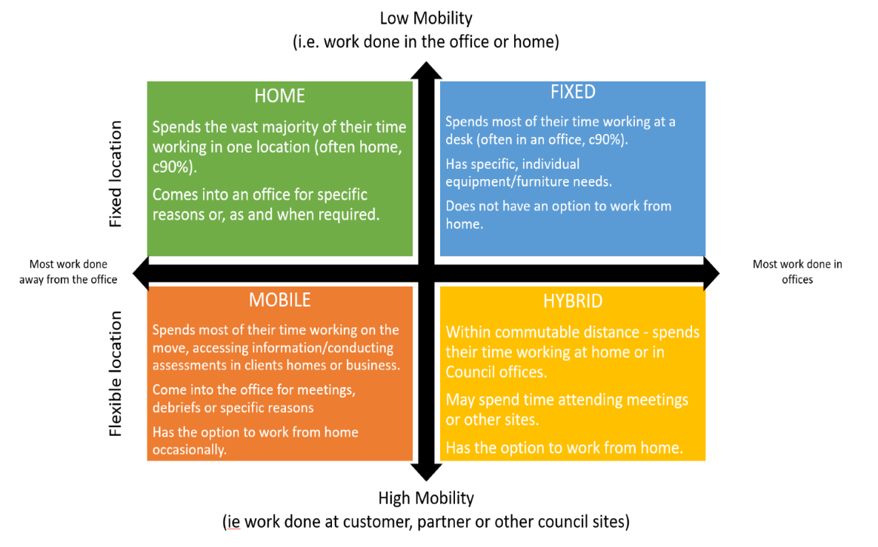

Our People Promise
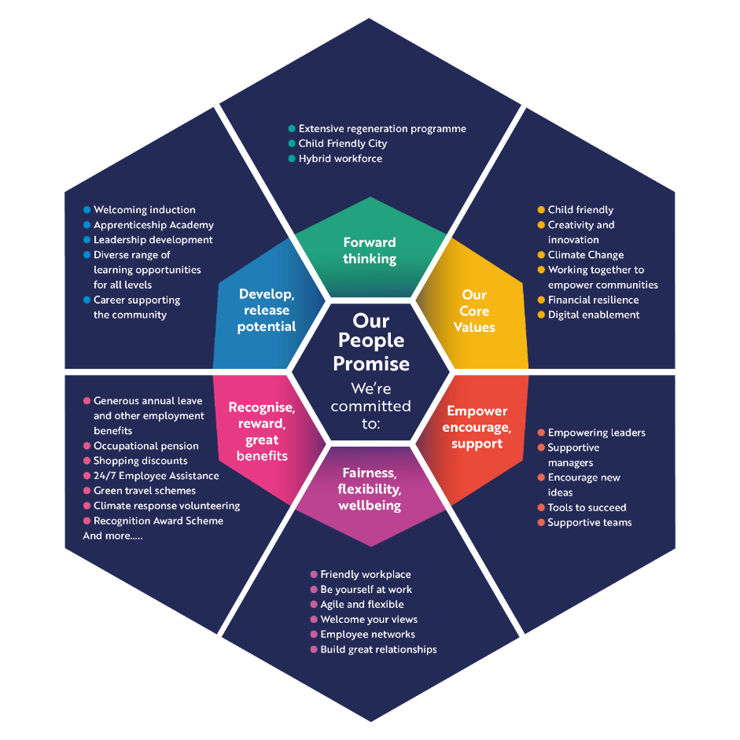

Employee benefits

Relocation package

In certain circumstances, and with prior agreement, Medway Council could provide assistance to support new employees moving home in order to take up their appointment. Terms and conditions apply, which can be accessed on request from recruitment@medway.gov.uk

Pension scheme

In most cases employees of Medway Council have the option to join the Local Government Pension Scheme (‘LGPS’). Employees under Teachers’ terms and conditions of employment will be eligible to join the Teachers’ pension scheme. The LGPS scheme will be jointly contributed to by the employee (% rate dependent on salary) and the Council, at the current rate of 18.3% of salary. Full details on the LGPS can be found by visiting www.kentpensionfund.co.uk

Care first employee assistance

Care First confidential counselling is available free to all employees 24 hours a day, 365 days of the year – calls or online request will be answered by a professional and there is no limit to the number of times you can contact them. In addition to counselling, Care first offer a number of different services including mediation, stress management, money advice line.

Childcare Vouchers
As an employer we share your concerns about balancing your working life with the demands made on you as a parent. With this in mind and to enhance our family friendly employment policies we operate a childcare voucher scheme. The scheme operates on a salary sacrifice basis, which means you exchange part of your salary for vouchers to use for childcare.
Learning and development

As part of Medway Council’s continued commitment to lifelong learning all employees are guaranteed a minimum of five days’ learning and development per year.

Shopping Discount Scheme

Every employee can access a range of discounts via the Medway More 4 You scheme - from high street stores and banks, as well as local services.

Reduced rate/interest free loans

As part of Medway Council’s Travel Plan a number of reduced rate/interest free loans may be available these include:-

- Annual train season tickets
- Assisted car purchase scheme
- Bicycle, scooter and motorcycle interest free loans

Access to Work

Access to Work is a government-run programme delivered by Jobcentre Plus to help overcome barriers that disabled people come across in getting or keeping work.
If the help you need at work is not covered by your employer making reasonable adjustments, you may be able to get help from Access to Work.
You’ll be offered support based on your needs, which may include a grant to help cover the costs of practical support in the workplace. Your workplace can include your home if you work from there some, or all, of the time.
Further information on Access to Work.

Staff Forums

Our staff forums are aimed specifically at employees from minority ethnic communities; or who consider themselves to have a disability, impairment or long-term health condition; or who are lesbian, gay, bisexual or transgender, questioning, intersex or from a specific gender.

Minority groups are generally under-represented in many workforces. As a result, individuals can end up feeling isolated or excluded. Having these forums gives the Council further opportunity to support staff from these groups to enable them to carry out their duties and responsibilities in an inclusive and accessible working environment without fear of discrimination. The forums also undertake valuable work in policy making, helping to ensure that the Council’s policies, procedures and services are fair and value diversity.

The Immigration Act 2016
As an equal opportunities employer Medway Council actively seeks to provide equal opportunity and access to all. Whilst we have put into place procedures to avoid discrimination in recruitment processes, we must also ensure that the people we employ have a legal right to work in the UK.
From 1 January 2021, non-British or Irish nationals, without a UK immigration status, were required to obtain a visa in order to work in the UK. The new points-based system treats EEA and non-EEA citizens equally. For further information please visit the UK Visas & Immigration website.

MEDWAY COUNCIL - Rehabilitation of Offenders Act 1974 (Exceptions Order) 1975 (as amended 2013) and the Police, Crime, Sentencing and Courts Act 2022

Treatment of Ex-Offenders - Information for Candidates

At Medway Council we aim to promote equality of opportunity for all with the right mix of talent, skills and potential, and welcome applications from ex-offenders. Criminal records will only be taken into account, for recruitment purposes, when they are relevant to the post for which you are applying. Otherwise, consideration for employment will be on merit and ability.

To check what information you need to declare to an employer: Check if you need to tell someone about your criminal record.

DBS Checks

In addition to you volunteering any information regarding your criminal record, appointments to some of our posts are subject to the receipt of a satisfactory criminal disclosure. DBS Standard and Enhanced disclosures will both detail cautions, reprimands and formal warnings, as well as convictions. An Enhanced Disclosure will also detail other relevant non-conviction information, such as police enquiries and details of any prosecutions pending.

Our recruitment advertising will specify which level of disclosure check will be required for the post you are applying for.

Subsequent checking

Further criminal disclosure checks will be obtained at three yearly intervals (or annually if registered with the DBS Update Service) whilst the employee remains in a relevant post. If a criminal record is subsequently disclosed, an investigation will be carried out to ascertain whether the employee is suitable for continued employment in the post.

Security of Disclosure Information

In accordance with the DBS Code of Practice, the council has a policy for ensuring this information is held confidentially and securely. The DBS Code of Practice is published on the DBS website.

Assessing the relevance of criminal records

In assessing a candidate's (with a criminal record) suitability for employment, depending on the nature of the job and the details and circumstances of any convictions, the council will take into account their skills, experience and conviction circumstances and weigh it against the element of risk for the job. For example, paedophile, or child pornography offences would disqualify anyone required to work with children; some violent offences would be relevant to positions involving unsupervised contact with the public, fraud would be considered in relation to posts involving the handling of money, and theft in relation to posts involving the handling of stock. These are a few examples and the list is not exhaustive.

Whilst it may not be possible to carry out a complete assessment on each individual, the Council will ensure that the following issues are taken into account when assessing the suitability of an applicant with a criminal record for a vacancy.

- the seriousness of the offence and its relevance to the safety of other employees, customers, clients and property;

- the length of time since the offence occurred;

- any relevant information offered by the applicant about the circumstances which led to the offence being committed, for example the influence of domestic or financial difficulties;

- whether the offence was a one-off, or part of a history of offending;

- whether the applicant's circumstances have changed since the offence was committed, making re-offending less likely;

- the country in which the offence was committed, some activities are offences in Scotland and not in England and Wales, and vice versa;

- whether the offence has since been decriminalised by Parliament;

- the degree of remorse, or otherwise, expressed by the applicant and their motivation to change.

If it is the case that following a criminal disclosure check, information appearing on a DBS certificate contradicts that provided by the applicant, this will be discussed as part of a post-interview process with the applicant and recruiting manager.

Any questions?

We hope that all the above information has given you everything you wish to know about working at Medway Council, however, if you have any further questions, please contact us at recruitment@medway.gov.uk.

