MEDWAY COUNCIL - JOB PROFILE

JOB TITLE | Referral Information Officer
DIRECTORATE | Children and Adults
SERVICE | First Response and Family Solutions
RESPONSIBLE TO | Team Manager
GRADE | Range 3
JOB FAMILY/ LEVEL | ORG001
AIN PURPOSE OF JOB
MAIN PURPOSE OF JOB

To provide a high quality response to written and telephone contacts from professionals and individuals relating to safeguarding concerns about children.

To act as a first point of contact for our callers and referring professionals taking responsibility for clarifying and recording concerns and family details, summarising information and where required, setting up client records.

To undertake all checks as required, ensuring accurate information is obtained and recorded.

To provide complete and comprehensive administration support to the Multi Agency Safeguarding Hub (MASH)

To administer processes and procedures using available equipment and ICT packages to meet organisational standards and requirements.

There may be a requirement to work at other sites within Medway, dealing face to face with council customers.

KEY CORPORATE ACCOUNTABILITIES

To actively promote work life balance and flexible working in order to achieve high quality service delivery.

To actively promote the Council's Fair Access, Diversity and Inclusion Policy and observe the standard of conduct which prevents discrimination taking place.

To ensure full compliance with the Health and Safety at Work etc Act 1974, the Council's Health and Safety Policy and all locally agreed safe methods of work.

To fully understand and be aware of the commitment to Section 17 of the duty of Crime and Disorder Act 1998 to prevent crime and disorder.

At the discretion of the Head of Service, such other activities as may from time to time may be agreed consistent with the nature of the job described above.

ACCOUNTABILITIES TO CHILDREN AND YOUNG PEOPLE

The children and young people of Medway have said the following qualities are really important to them:

- Be a good listener
- Be non-judgemental
- Be consistent and Stable
- Be contactable
- Understand me
- Be honest
- Be Focused
- Be realistic
- Be a good timekeeper
- Be resourceful in your approach

Be ambitious for young people and promote others to share the same drive.

Champion Children and Young People’s views and rights in everything you do.

Ensure Children and Young People’s voices are listened to and acted upon.

‘Do what you say and say what you do’.

PERSON SPECIFICATION

QUALIFICATIONS | Assessment Method
GCSE (or equivalent) in English and Mathematics, or an ability to demonstrate proficiency in both subjects (minimum Grade 5) | Application
NVQ Level 3 or above in Business Administration or related | Application
EXPERIENCE
Previous demonstrable experience of working face to face with members of the public and professional colleagues | Application / Interview
Experience of administrative functions including setting up meetings, minuting and record keeping, | Application / Interview
Previous experience of applying specialist, policy and procedural knowledge, across a wide range of activities. Ability to complete detailed assessments and summaries of relevant information | Application / Interview
Previous demonstrable experience of working in children’s services (Desirable) | Application
KNOWLEDGE
An understanding of local government and the services provided (Desirable) | Application
Ability to demonstrate awareness of legislation relating to General Data Protection Regulations and Freedom of Information | Application
SKILLS | Assessment Method
Ability to deal with considerable levels of work-related pressure, for example from high volumes of contacts, deadlines, interruptions or conflicting demands | Interview
Demonstrable ability to use own judgement and creativity to assess situations, solve straightforward problems and adapts to new ways of working | Interview
Demonstrable ability to use written and oral communication skills to present varied information in an understandable way to a range of audiences | Application / Interview
Demonstrable ability to work within defined procedures and to work independently, using initiative to deal with straightforward situations, referring to supervisor/line manager for unusual or difficult problems | Interview
Demonstrable ability to carry out tasks and/or advise on internal procedures, which impact on the health and wellbeing of people | Interview
Ability to use Microsoft Office packages as well as an electronic integrated children’s system (e.g. MOSAIC or similar) | Application
Ability to manage time and workload effectively | Interview
Understands and is committed to equality and diversity and treats everyone fairly and with respect | Interview
Ability to maintain confidentiality at all times | Interview

OTHER REQUIREMENTS
Standard DBS Check

ORGANISATION

(i) ORGANISATION CHART
See below:
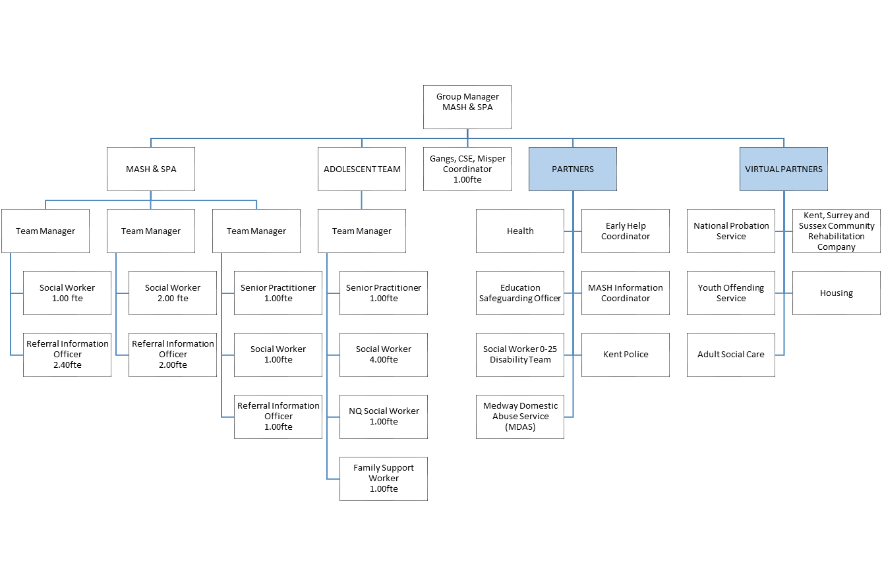

(ii) DESCRIBE HOW AND BY WHOM THE POST IS MANAGED
The post holder will be line managed by the Team Manager

(iii) DESCRIBE THE LEVEL OF INITIATIVE AND/OR INDEPENDENCE EXPECTED OF THE POST HOLDER
To work within defined procedures and to work independently, using initiative to deal with straightforward situations, referring to line manager for unusual or difficult problems

The post holder is expected to contribute to their own personal development, attend supervision and team meetings to include attending any identified training.

(iv) DESCRIBE ANY SUPERVISORY/MANAGEMENT RESPONSIBILITIES
You will be required to explain straightforward tasks to others, where required

(v) JOB CONTEXT - DESCRIBE THE MAIN CONTACTS, BOTH INTERNAL AND EXTERNAL AND THE PURPOSE OF THOSE CONTACTS
Internal contacts will include colleagues, all levels of management up to director level, elected members etc. External contacts would be professional colleagues from partner agencies, members of the public, other local authorities, voluntary bodies.

FINANCIAL ACCOUNTABILITIES
No direct financial accountabilities, although the post holder may be required to administer the collection and processing of small sums money.

The post holder may also be required to undertake the ordering of goods and supplies using the recognised purchase order system, raising purchase order numbers and completing invoices in line with the Council’s financial procedures.

WORKING ENVIRONMENT
The post holder will be office based but may be expected to travel to other Council sites as and when required.

The post holder will be expected to keep his or her own workstation and space clean and tidy.

The post holder, may encounter some verbal aggression or emotional demands from members of the public.

