**MEDWAY COUNCIL - JOB PROFILE**

|  |  |
| --- | --- |
| **JOB TITLE** | Senior Practitioner |
| **DIRECTORATE** | Children and Adults |
| **SERVICE** | 0-25 Disability Service |
| **RESPONSIBLE TO** | Team Manager |
| **GRADE** | SW3 |
| **JOB FAMILY** | PSW0251 |

**AIN PURPOSE OF JOB**

|  |
| --- |
| **MAIN PURPOSE OF JOB** |

Manage and hold a caseload of complex cases within our 0-25’s disability service ensuring that our children and young adults with disabilities are safeguarded and supported to achieve their full potential.

To work closely with multi agency partners such as Health and Education, to ensure children and young adults with disabilities receive the services they require to allow them to thrive and have a voice as valued members of our community.

Offer expert advice and support to less experienced staff on aspects of casework and where appropriate act as a Practice Assessor for students on placement.

|  |
| --- |
| **ACCOUNTABILITIES** |

Manage a caseload of complex cases, undertaking focused, analytical assessments, plans and reviews that have clear objectives and outcome measures in order to ensure that all children and young adults with disabilities receive a service that reflects the Council’s commitment to child and adult safeguarding and meaningful transition into young adulthood.

Demonstrate and model a high standard of practice that reflects a value based and child-centred approach to working with disabled children, young adults and their families, in recognition of the Children Act 1989, Children and Families Act 2014, and Care Act 2014.

To work directly with disabled children and disabled young adults to establish their wishes and feelings, using a variety of techniques, as required.

To be a Signs of Safety Champion and consistently use the Signs of Safety practice model to improve the outcomes and safety of children.

Provide expert advice and support to less experienced staff on aspects of casework and where appropriate act as a Practice Assessor for students on placement, ensuring a high level of practice is demonstrated.

Prepare clear, structured and concise reports for meetings, i.e. Child Protection Conferences, Children and Adult strategy meetings, Adult Safeguarding Meetings, Adult Best Interest Meetings, Looked After Children Reviews, Children in Need meetings, and court proceedings as necessary, to the required standard and within the prescribed timescales.

Participate in regular supervision to review case work and critically reflect on the work being undertaken.

.

Keep up to date with research findings, theoretical models and innovative practice within the social work field in order to maintain the highest professional standards.

To maintain accurate and up to date records in line with Data Protection legislation (GDPR) and use Medway Council specific recording systems to promote effective case management

Contribute to service development in line with local plans, initiatives and strategies.

|  |
| --- |
| **KEY CORPORATE ACCOUNTABILITIES** |

To work with colleagues to achieve service plan objectives/targets

To participate in one-to-one Performance Development Reviews and contribute to the identification of own and team development needs

To actively promote the Council's Fair Access, Diversity and Inclusion Policy and observe the standard of conduct which prevents discrimination taking place

To ensure full compliance with the Health and Safety at Work Act 1974, the Council's Health and Safety Policy and all locally agreed safe methods of work

To fully understand and be aware of the commitment to the duty under Section 17 of the Crime and Disorder Act 1998 to prevent crime and disorder

At the discretion of the Head of Service, such other activities as may from time to time be agreed consistent with the nature of the job described above

|  |
| --- |
| **ACCOUNTABILITIES TO CHILDREN AND YOUNG PEOPLE** |

The children and young people of Medway have said the following qualities are really important to them:

* Be a good listener
* Be non-judgemental
* Be consistent and Stable
* Be contactable
* Understand me
* Be honest
* Be Focused
* Be realistic
* Be a good timekeeper
* Be resourceful in your approach

Be ambitious for young people and promote others to share the same drive.

Champion Children and Young People’s views and rights in everything you do.

Ensure Children and Young People’s voices are listened to and acted upon.

‘Do what you say and say what you do’.

**PERSON SPECIFICATION**

|  |  |
| --- | --- |
| **QUALIFICATIONS** | **Assessment Method** |
| Qualified Social Worker with post qualifying training. | Application |
| Registration with Social Work England | Application |
| PEPS 2 or commitment to work towards | Application |
| **EXPERIENCE** |  |
| Demonstrable post qualification experience of working with disabled children and their families | Application |
| Demonstrable experience of undertaking direct work with children and young people. | Application / Interview |
| Demonstrable experience in child protection and court work. | Application / Interview |
| Proven experience in the application of ‘Signs of Safety’ or commitment to undertake training | Application |
| Proven experience in providing expert advice and support to less experienced staff on aspects of casework and where appropriate act as a Practice Assessor for students on placement. | Application |
| **KNOWLEDGE** |  |
| Demonstrable knowledge required to recognise and evaluate risk to disabled children and disabled young adults and assess measures to reduce that risk. | Application / Interview |
| Demonstrable knowledge of legislation and statutory guidance relevant to working in children’s and young adult services and more specifically in relation to disabled children and young people | Application / Interview |
| Demonstrable knowledge of key points of transition in relation to disabled children and young adults. | Interview |
| Demonstrable knowledge of national policy in relation to young adult work and adult safeguarding developments in relation to the Care Act 2014. | Interview |
| Demonstrable knowledge and experience in the application of relevant theoretical frameworks, practice models and research findings | Interview |
| Ability to demonstrate awareness of legislation relating to General Data Protection Regulations and Freedom of Information | Application |
| Knowledge of disability and the impact that this can have on children, young adults and their families. | Interview |
| **SKILLS** | Assessment Method |
| Demonstrable ability to build sound, productive working relationships with colleagues, partners and employees. | Interview |
| Uses advanced theoretical / practical / procedural / organisational / policy knowledge across a specialist area and has detailed knowledge of organisational policies, practices or procedures | Interview |
| Engages effectively with children and families and has experience of using different tools and methodologies to communicate with children and young people | Interview |
| Ability to work within a court setting and other professional settings. | Interview |
| Ability to write high quality written reports which are suitable for a variety of professional settings. | Interview |
| Ability to analyse and interpret varied and highly complex information, developing strategies and solutions for long term plans | Interview |
| Ability to use highly developed communication skills to confidently present complex/sensitive information in an understandable way, adapting the style to a range of audiences and stakeholders. | Interview |
| Competent in the use of Microsoft Office packages as well as an electronic integrated children’s system (eg: MOSAIC or similar) | Application |
| Ability to manage time and workload effectively | Interview |
| Understands and is committed to equality and diversity and treats everyone fairly and with respect | Interview |
| Ability to maintain accurate and up to date case records. | Interview |
| Ability to demonstrate a commitment to individual and reflective supervision. | Interview |
| Ability to maintain confidentiality at all times | Interview |
| **OTHER REQUIREMENTS** |  |
| Car driver and use of a car for business purposes | Application |
| Commitment to continuous professional development and the acquisition of advanced and specialist skills and knowledge | Interview |
| An understanding of Social Work England’s professional standards and a commitment to upholding them in your practice. | Application |
| Enhanced DBS check |  |

**2. ACCOUNTABILITY**

MERGE05

**ORGANISATION**

### **(i) ORGANISATION CHART**

See Below:

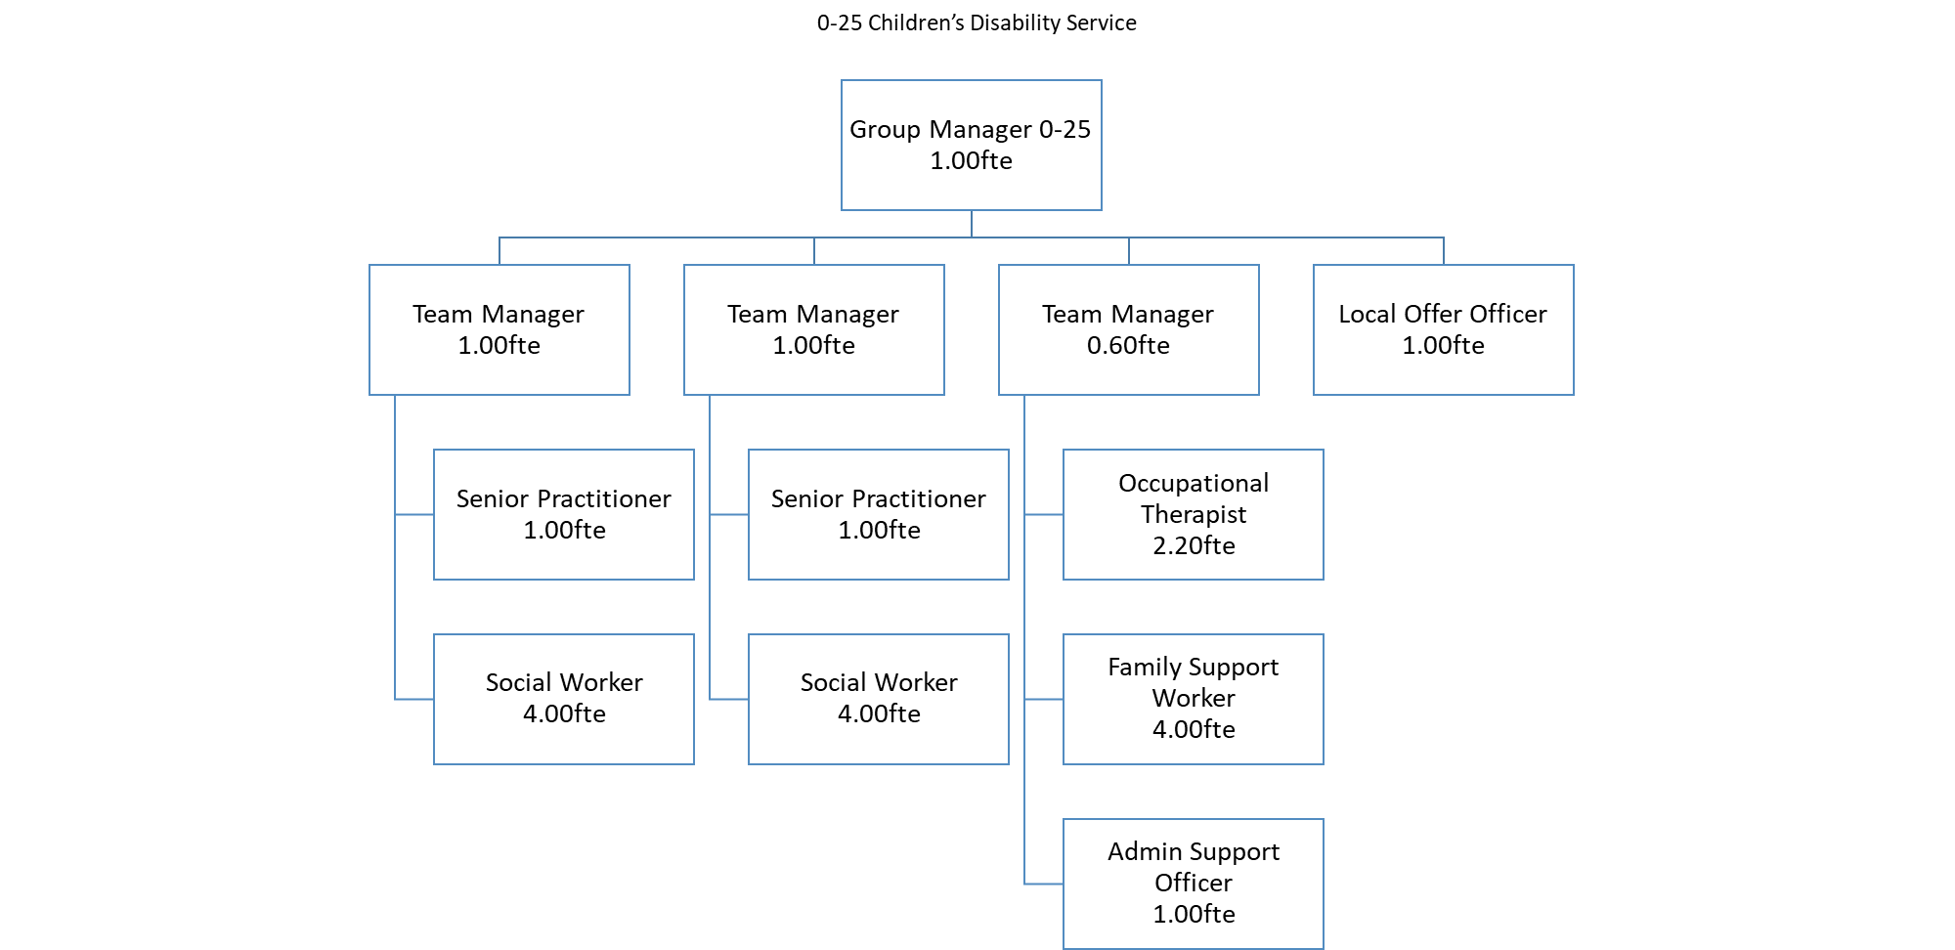

### **(ii) DESCRIBE HOW AND BY WHOM THE POST IS MANAGED**

The post holder will be line managed by the Group Manager

### **(iii) DESCRIBE THE LEVEL OF INITIATIVE AND/OR INDEPENDENCE EXPECTED OF THE POST HOLDER**

Ability to work independently within clear guidelines and regularly uses initiative to make decisions, referring to more senior officers for advice on policy/resource issues.

**(iv) DESCRIBE ANY SUPERVISORY/MANAGEMENT RESPONSIBILITIES**

No direct line management responsibilities. The post holder will be required to provide support to less experienced staff on aspects of casework and where appropriate act as a Practice Assessor for students on placement.

### **(v) JOB CONTEXT - DESCRIBE THE MAIN CONTACTS, BOTH INTERNAL AND EXTERNAL AND THE PURPOSE OF THOSE CONTACTS**

The post holder will be required to liaise with all stakeholders both internal and external to the organisation, including working with children and families to ensure they are appropriately involved in decisions.

## **FINANCIAL ACCOUNTABILITIES**

None; however the post holder must have the ability to understand cost implications of resource allocation, financial packages and make recommendations to managers about efficient and cost effective use of resources.

## **WORKING ENVIRONMENT**

The post holder will be based in one of Medway Council’s establishments.