**MEDWAY COUNCIL - JOB PROFILE**

|  |  |
| --- | --- |
| **JOB TITLE** | Social Worker (Experienced) |
| **DIRECTORATE** | Children & Adults |
| **SERVICE AREA** | MASH & SPA |
| **RESPONSIBLE TO** | Team Manager |
| **GRADE** | SWCS2 |
| **JOB FAMILY/LEVEL** | PSW0254 |

|  |
| --- |
| **MAIN PURPOSE OF JOB** |

To safeguard vulnerable children and support them to achieve their full potential, living within their family if safe to do so.

To provide a high quality and effective professional casework service, taking responsibility for working and managing a caseload within a framework of appropriate supervision, dependent upon the complexities of these cases and the social worker’s experience.

To comply with legislation, statutory guidance and local policies and procedures

To be competent in all areas of the PCF at Social Worker level and The Knowledge and Skills Statement (KSS) for approved child and family practitioners.

|  |
| --- |
| **ACCOUNTABILITIES** |

Manage a caseload within a framework of appropriate reflective supervision, undertaking focused, analytical assessments, SMART plans and reviews that have clear objectives and outcome measures in order to ensure that all vulnerable children receive a service that reflects the Council’s commitment to safeguarding and putting the needs of individual children first.

Demonstrate and model good practice that reflects a commitment to relationship and strengths based practice, working collaboratively with children, young people and their families.

Work directly with children and young people to establish their wishes and feelings, using a variety of techniques, as required.

Consistently use the Signs of Safety practice model in assessments and interventions with children and their families.

.

Maintain accurate and up to date records in line with Data Protection legislation (GDPR) and use Medway Council specific recording system’s to promote effective case management.

Prepare clear, structured and concise reports for meetings, i.e. Child Protection Conferences, strategy meetings, Looked After Children Reviews, Children in Need meetings, and court proceedings as necessary, to the required standard and within the prescribed timescales.

Keep up to date with research findings, theoretical models and innovative practice within the social work field in order to maintain the highest professional standards.

Participate in regular supervision with your manager to review casework and critically reflect on, and identify any areas of learning.

Maintain a record of continuous professional development in accordance with Social Work England’s guidance.

Keep up to date with the Council’s organisational policies, government guidance, legislation, research and national trends in order to maintain the highest professional standards.

|  |
| --- |
| **KEY CORPORATE ACCOUNTABILITIES** |

To work with colleagues to achieve service plan objectives/targets

To participate in one to one Performance Development Reviews and contribute to the identification of own and team development needs

To actively promote the Council's Fair Access, Diversity and Inclusion Policy and observe the standard of conduct which prevents discrimination taking place

To ensure full compliance with the Health and Safety at Work Act 1974, the Council's Health and Safety Policy and all locally agreed safe methods of work

To fully understand and be aware of the commitment to the duty under Section 17 of the Crime and Disorder Act 1998 to prevent crime and disorder

At the discretion of the Head of Service, such other activities as may from time to time be agreed consistent with the nature of the job described above

|  |
| --- |
| **ACCOUNTABILITIES TO CHILDREN AND YOUNG PEOPLE** |

The children and young people of Medway have said the following qualities are really important to them:

* Be a good listener
* Be non-judgemental
* Be consistent and Stable
* Be contactable
* Understand me
* Be honest
* Be Focused
* Be realistic
* Be a good timekeeper
* Be resourceful in your approach

Be ambitious for young people and promote others to share the same drive.

Champion Children and Young People’s views and rights in everything you do.

Ensure Children and Young People’s voices are listened to and acted upon.

‘Do what you say and say what you do’.

**PERSON SPECIFICATION**

|  |  |  |
| --- | --- | --- |
| **QUALIFICATIONS** | | **Assessment Method** |
| Qualified Social Worker. | | Application |
| Successful completion of ASYE year | | Application |
| Working towards Practice Educator Professional Standards *(Desirable)* | | Application |
| Registration with Social Work England | | Application |
| **EXPERIENCE** | |  |
| Demonstrable post qualification experience of working with children and families (minimum of 2 years) | | Application |
| Proven experience in the use of ‘Signs of Safety’ or a willingness to be trained | | Application |
| Demonstrable experience of undertaking direct work with children and young people and being able to evidence understanding of the child’s lived experience. | | Application / Interview |
| Demonstrable experience in child protection and court work. | | Application / Interview |
| Demonstrable experience in relationship and strengths-based practice, working collaboratively with children, young people and their families | | Application / Interview |
| Proven experience in one or more areas of practice and have a broader knowledge of local and national resource networks | | Application/ Interview |
| **KNOWLEDGE** | |  |
| Ability to use advanced theoretical/practical/procedural/ organisational /policy knowledge across a specialist area | | Application |
| Knowledge and experience of working with vulnerable children in a statutory setting. | | Application / Interview |
| Knowledge and experience in the application of relevant legislation, statutory guidance, standards and local policies and procedures. | | Application / Interview |
| Demonstrable knowledge and experience in the application of relevant theoretical frameworks, practice models and research findings | | Interview |
| Ability to demonstrate awareness of legislation relating to General Data Protection Regulations and Freedom of Information | | Application |
| Demonstrable knowledge required to recognise and evaluate risk to children and assess measures to reduce that risk | | Application/ interview |
| **SKILLS** | | **Assessment Method** |
| Demonstrates well developed skills in collecting and analysing information, assessing children and families’ needs and creating imaginative responses and interventions. | | Interview |
| Demonstrable ability to build sound, productive working relationships with colleagues, partners and other staff. | Interview | |
| Engages effectively with children and families and has experience of using different tools and methodologies to communicate with children and young people | Interview | |
| Ability to maintain accurate and up to date case records in a timely manner | Interview | |
| Ability to write good quality written reports which are suitable for a variety of professional settings. | Interview | |
| Ability to analyse and interpret varied and complex information, developing strategies and solutions for the medium and long term | Interview | |
| Ability to use well developed communication skills to present complex/sensitive information in an understandable way, to a range of audiences | Interview | |
| Competent in the use of Microsoft Office packages as well as an electronic integrated children’s system (eg: MOSAIC or similar) | Application | |
| Ability to practice effectively and competently with an increasing level of autonomy and independence | Interview | |
| Ability to make good quality judgements and sound decisions in situations of increasing complexity, risk, uncertainty and challenge, and be able to effectively explain and justify decisions. | Interview | |
| Ability to evidence use of relationship building and strengths based practice in assessments and interventions with children and their families. | Interview | |
| Ability to carry out tasks which impact on the wellbeing of people, including assessing needs, implementing care/welfare, implementing regulations, providing guidance on internal procedures and interpreting policies and procedures to meet specific circumstances or problems. | Interview | |
| Ability to work under pressure and manage time and workload effectively. | | Interview |
| Ability to work within a court settings and other professional settings. | | Interview |
| Ability to work effectively as part of a team to achieve team and service plan objectives and targets. | | Interview |
| Ability to maintain confidentiality at all times | Interview | |

## **2. ACCOUNTABILITY**

MERGE05

|  |  |
| --- | --- |
| **OTHER REQUIREMENTS** | **Assessment Method** |
| Car driver and daily use of a car for business purposes | Application |
| Commitment to continuous professional development | Interview |
| Ability to demonstrate a commitment to individual and reflective supervision | Interview |
| An understanding of Social Work England’s professional standards and a commitment to upholding them in your practice. | Application |
| Enhanced DBS check |  |

**ORGANISATION**

### **ORGANISATION CHART**

See Below:

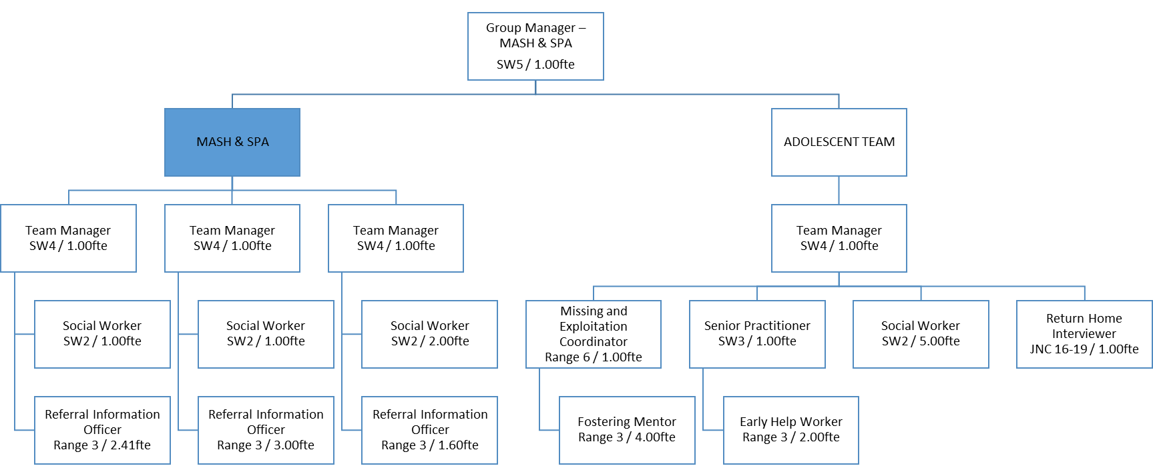

### **DESCRIBE HOW AND BY WHOM THE POST IS MANAGED**

The post holder will be line managed by the Team Manager.

### **DESCRIBE THE LEVEL OF INITIATIVE AND/OR INDEPENDENCE EXPECTED OF THE POST HOLDER**

The post holder will manage his/her own time effectively working directly with a broad range of partner agencies and other departments in Children’s Services using his/her own initiative to ensure procedures are followed and targets are met.

### **DESCRIBE ANY SUPERVISORY/MANAGEMENT RESPONSIBILITIES**

The post holder will have no direct line management responsibility

### **JOB CONTEXT - DESCRIBE THE MAIN CONTACTS, BOTH INTERNAL AND EXTERNAL AND THE PURPOSE OF THOSE CONTACTS**

The post holder will be required to liaise with all stakeholders both internal and external to the organisation.

## **FINANCIAL ACCOUNTABILITIES**

None; however the post holder must have the ability to understand cost implications of resource allocation, financial packages and make recommendations to managers about efficient and cost effective use of resources.

## **WORKING ENVIRONMENT**

The post holder will be based in one of Medway Council’s establishments