MEDWAY COUNCIL - JOB PROFILE

Designation:- Housing Options Triage Officer
Directorate;- Regeneration, Community and Culture
Department:- Strategic Housing Services
Responsible to:- Housing Options Team Leader
Salary:- Range 3

- Main purpose of job
To provide initial housing advice to households and details of suitable housing options in the private and public sector, including information on homelessness prevention.
To act in a supporting capacity to our Housing Options Officers carrying out homelessness needs assessments.
You will be responsible for conducting appointments with members of the public and assessing if they are homeless or at risk of homelessness.
To provide information and advice on support services available and provide assistance in exploring various housing options.
To complete enquiries to support the Housing Options Officers to assess homelessness applications.
To be able to adapt working practises to work with vulnerable people who are homeless or threatened with homelessness.

2. PERSON SPECIFICATION

Qualifications
Essential
• Good level of general education (GCSE Grade A* - C) including Maths and English

Experience
Essential
- Knowledge of housing and homelessness legislation such as the Housing Act 1996; Homelessness Code of Guidance; Protection from Eviction Act 1977; and Homelessness Reduction Act 2017.
- Experience of working directly with vulnerable households including young people.
- Experience of using computers and differing bespoke software applications.
- Experience of dealing with, and supporting, customers facing homelessness.
Desirable
- Full UK driving licence and use of own car for work purposes
- Experience of conducting in-depth interviews to obtain information and validate evidence
- Experience of undertaking support needs and welfare assessments

Skills
Essential
- Demonstrable ability to analyse and interpret complex information and situations. Ability to develop solutions and plans for the medium term. Adopts an imaginative and innovative approach.
- Demonstrable ability to use well developed communication skills to present complex/sensitive information in an understandable way, to a range of audiences
- Demonstrable ability to work independently within defined procedures, and work outside of procedures, making decisions without referring to a supervisor/line manager, where necessary.
- Demonstrable ability to carry out tasks which impact on the wellbeing of people, including assessing needs, implementing care/welfare, implementing regulations, providing guidance on internal procedures and interpreting policies and procedures to meet specific circumstances or problems.
- Demonstrates the ability to either: (i) deal with high levels of work-related pressure, for example from deadlines, interruptions or conflicting demands, or
(ii) the equivalent of periods of hours at a time (e.g. a morning or afternoon) undertaking repeated manual calculations or other work with figures, or report writing or preparing for a presentation, or
(iii) all or most of the working day spent on being alert to risks or checking of documents or equivalent.
- Can demonstrate dexterity, co-ordination or sensory skills, where there is some demand for precision in the use of these skills, for example driving and/or the general use of a computer during the working day.

3. ORGANISATION

(i) ORGANISATION CHART
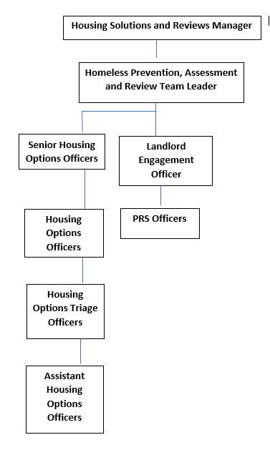

(ii) DESCRIBE HOW AND BY WHOM THE POST IS MANAGED
The post holder will be line managed by the Housing Options Team Leader

(iii) DESCRIBE THE LEVEL OF INITIATIVE AND/OR INDEPENDENCE EXPECTED OF THE POST HOLDER
The post holder must be able to work under own initiatives but within the team's policies and procedures.

(iv) DESCRIBE ANY SUPERVISORY/MANAGEMENT RESPONSIBILITIES
None

(v) JOB CONTEXT - DESCRIBE THE MAIN CONTACTS, BOTH INTERNAL AND EXTERNAL AND THE PURPOSE OF THOSE CONTACTS
The post holder will maintain a wide range of internal and external contacts in the provision of services. Internally there will be daily contact with the Team Leader, PRS, Housing Options, and Temporary Accommodation Team members, and more generally with Officers within the wider Strategic Housing Service.
This post will assist in the development and maintenance of multi-directorate and multi-agency working and contact will involve liaison with members of the public.
EMOTIONAL DEMANDS
You will undertake work which has from time-to-time contact with, or work for, other people (other than immediate work colleagues) which, through their personal circumstances or behaviour place emotional demands on the jobholder. (Personal behaviour at this level may include a person who is upset because of their personal circumstances, unwell or has a disability.).

4. FINANCIAL ACCOUNTABILITIES
The post holder will not have specific responsibility for the budget

5. WORKING ENVIRONMENT
The post holder will be based at Kingsley House, Gillingham. In some cases the jobholder can work from home, however much of this role is face to face with members of the public, and appointments are carried out at Kingsley House.

