MEDWAY COUNCIL - JOB PROFILE

JOB TITLE | Team Manager (Practice Development) – Family Solutions
DIRECTORATE | Children and Adults
SERVICE AREA | Family Solutions
RESPONSIBLE TO | Group Manager
GRADE | SW4
JOB FAMILY/LEVEL | PSW0251

MAIN PURPOSE OF JOB

To line manage, support and coach a team of social workers that includes experienced staff and newly qualified workers, in order to ensure the correct procedures are implemented which support positive outcomes for children, young people and families.

To contribute towards delivering the council’s vision for Children’s Social Care in order to ensure the objectives and priorities are realised.

To work together with partners delivering a range of targeted help, family support and effective interventions which build resilience, remove barriers and enable children and young people to look forward to a brighter future.

To embed best practice through the provision of supervision, observed practice, training and developing practice throughout the Family Solutions service.

Targeted Help within the Family Solutions Service is supported with a culture of collaboration, integrity and compassion and promoting the development and wellbeing of children, young people and their families.

ACCOUNTABILITIES
To model good practice that reflects a value-based approach to working with children and their families that is child-centred.

Lead, manage and motivate a staff team, ensuring high quality professional supervision and performance development plans are completed which enhance individuals personal and professional development needs and contributes towards staff retention.

Manage and oversee the performance of your team effectively using available team performance data to monitor standards and performance and ensure compliance with practice standards and procedures.

Contribute to the management of the staffing budget for the team by approving and committing expenditure within your delegated authority, and monitoring and reporting commitments in order to ensure budget is not exceeded.

Support the safer recruitment and selection of new staff, within the team and across Family Solutions in order to ensure staffing levels are maintained.

Provide an effective service to children, young people and their families ensuring assessments and planned reviews are completed to a high standard and in accordance with timescales.

Lead on the practice development for Family Solutions Staff and other staff within the multi-disciplinary staff team, incorporating research/evidence-based approach to ensure high quality and consistent application of practice.

Undertake quality assurance work to ensure the provision of high-quality support to children and their families.

Work with staff and partners to ensure effective risk management in line with Kent and Medway Safeguarding Children Procedures

Review, support and drive delivery of relevant parenting programmes and contribute to the Council’s parenting strategy in order to ensure evidence-based parenting support and programmes are accessible and delivered across Medway.

Work collaboratively with the Group Manager to improve the level of consistent practice within the team in order to achieve high performance standards delivered through good quality services provided to children and families.

Jointly manage the Family Solutions hub within the Single Point of Access (SPA) service in order to ensure consistent threshold application and decision making.

To be competent in all areas of the Professional Capabilities framework at Advanced Social Work level.

KEY CORPORATE ACCOUNTABILITIES

To actively promote work life balance and flexible working in order to achieve high quality service delivery

To actively promote the Council's Fair Access, Diversity and Inclusion Policy and observe the standard of conduct which prevents discrimination taking place.

To ensure full compliance with the Health and Safety at Work etc Act 1974, the Council's Health and Safety Policy and all locally agreed safe methods of work.

To fully understand and be aware of the commitment to Section 17 of the duty of Crime and Disorder Act 1998 to prevent crime and disorder.

At the discretion of the Head of Service, such other activities as may from time to time may be agreed consistent with the nature of the job described above.

ACCOUNTABILITIES TO CHILDREN AND YOUNG PEOPLE

The children and young people of Medway have said the following qualities are really important to them:

- Be a good listener
- Be non-judgemental
- Be consistent and Stable
- Be contactable
- Understand me
- Be honest
- Be Focused
- Be realistic
- Be a good timekeeper
- Be resourceful in your approach

Be ambitious for young people and promote others to share the same drive.

Champion Children and Young People’s views and rights in everything you do.

Ensure Children and Young People’s voices are listened to and acted upon.

‘Do what you say and say what you do’

PERSON SPECIFICATION

QUALIFICATIONS | Assessment Method
Qualified Social Worker with post qualifying training. | Application
Registration with Social Work England | Application
Management qualification and/or evidence of appropriate experience and willingness to complete training. | Application
Practice Educator Professional Standards (PEPS) or working towards | Application
EXPERIENCE
Demonstrable post qualification experience of working with children and families | Application
Proven experience in the application of ‘Signs of Safety’ (Desirable) | Application
Demonstrable experience of undertaking direct work with children and young people and being able to evidence understanding of the child’s lived experience. | Interview
Demonstrable experience of managing and delivering professional supervision to social workers and other staff. | Application / Interview
Proven experience of performance management. | Interview
Provide experience in supporting student placements | Application
KNOWLEDGE
Knowledge and experience of working with vulnerable children in a non-statutory setting. | Application/  interview
Demonstrating a comprehensive and up to date understanding of all relevant legislation, regulation and guidance | Application/ interview
Good operational understand of effective risk management including risk of harm to children and risk of harm to others | Interview
Demonstrable knowledge and experience in the application of relevant theoretical frameworks, practice models and research findings | Interview
Ability to demonstrate awareness of legislation relating to General Data Protection Regulations and Freedom of Information | Application
SKILLS
Demonstrates well developed skills in collecting and analysing information, assessing children and families’ needs and creating imaginative responses and interventions. | Interview
Ability to develop the practice of staff to promote improved outcomes for children and families | Interview
Ability to initiate and develop close working partnerships with statutory, voluntary and private agencies to gather/ share information in order to facilitate decision making for effective service delivery. | Interview
Ability to deliver high quality training and development sessions to a multi-agency staff group with a view to improving integrated working practices. | Interview
Demonstrable commitment to involvement of children and families in decision making and to shape quality assurance of the service. | Interview
Ability to work effectively as part of a team to achieve team and service plan objectives and targets. | Interview
Demonstrable ability to build sound, productive working relationships with colleagues, partners and employees. | Interview
Ability to write high quality written reports which are suitable for a variety of professional settings. | Interview
Ability to analyse and interpret varied and highly complex information, developing strategies and solutions for long term plans | Interview
Ability to use highly developed communication skills to confidently present complex/sensitive information in an understandable way, adapting the style to a range of audiences and stakeholders. | Interview
Ability to allocate work and monitor progress, quality, standards and outcomes of work. | Interview
Proven experience of contributing to successful budget management | Interview
Ability to use Microsoft Office packages as well as an electronic integrated children’s system (eg: MOSAIC or similar) | Application
Ability to manage time and workload effectively | Interview
Understands and is committed to equality and diversity and treats everyone fairly and with respect | Interview
Ability to maintain confidentiality at all times | Interview

OTHER REQUIREMENTS | Assessment Method
Car driver and daily use of a car for business purposes | Application
An understanding of Social Work England’s professional standards and a commitment to uphold them in your practice. | Application
Commitment to continuous professional development | Interview
Enhanced DBS check

ORGANISATION

ORGANISATION CHART
See Below:
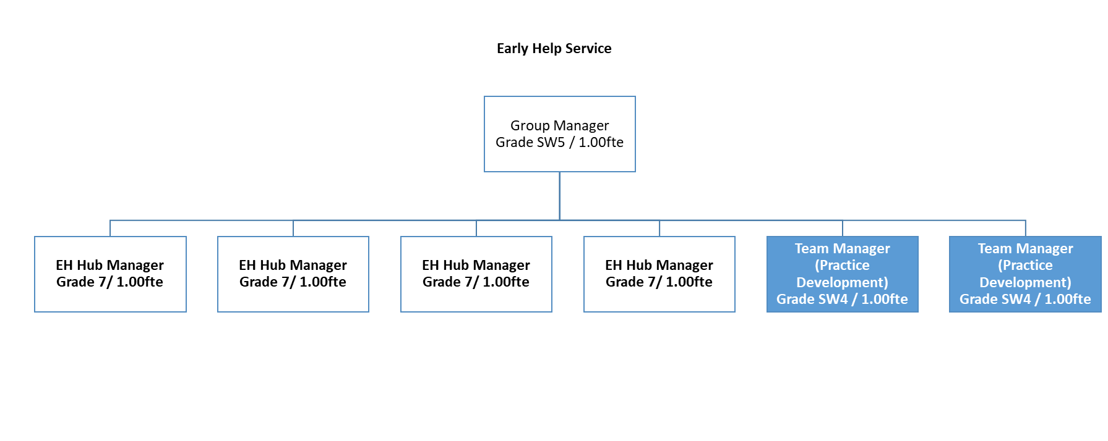

DESCRIBE HOW AND BY WHOM THE POST IS MANAGED
The post holder will be line managed by the Group Manager.

DESCRIBE THE LEVEL OF INITIATIVE AND/OR INDEPENDENCE EXPECTED OF THE POST HOLDER
The post holder will manage his/her own time effectively working directly with a broad range of partner agencies and other departments in Children’s Services using his/her own initiative to ensure procedures are followed and targets are met.

DESCRIBE ANY SUPERVISORY/MANAGEMENT RESPONSIBILITIES
The post holder will have line management responsibility of the parenting lead and qualified social workers

JOB CONTEXT - DESCRIBE THE MAIN CONTACTS, BOTH INTERNAL AND EXTERNAL AND THE PURPOSE OF THOSE CONTACTS
The post holder will be required to liaise with all stakeholders both internal and external to the organisation.

FINANCIAL ACCOUNTABILITIES
The post holder will contribute towards the management of the team budget including, monitoring and ensuring effective spend of budget.

WORKING ENVIRONMENT
The post holder will be based in one of Medway Council’s establishments.

